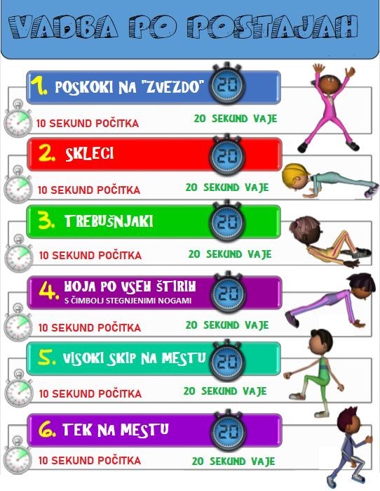
Zumba https://www.youtube.com/watch?v=M75HIuLeC9A
La Bamba https://www.youtube.com/watch?v=A-dtvDa_IWc

